All families will need to create a Parents Web account. This is our online location where you can see your student’s attendance records, grades, pay tuition, load money on the student’s lunch account, and more!  It’s important to set up your Parents Web account early in the year. Come springtime, this is also where you will re-enroll your student for the next academic year here at NFC.

1. To set up your Parents Web account, you’ll need to visit [www.nflschool.org](http://www.nflschool.org).

2. On the top of the page, you’ll see “Resources”; hover over the word and a drop-down menu will appear. Click on “Parents Web”.

3. On this next screen, click “Create New Parents Web Account”.  You’ll need to enter an email address, then click “Create Account”.

4. You’ll see a statement that says an email has been sent to the email account you just entered. The email will contain a link to create your username and password connected to your email address. You’ll need to click the link provided, then follow the instructions given to create your username and password.  The link that is only active for 6 hours.  
   
5. Once you’re set up in Parents Web, you should see a screen that looks like below:

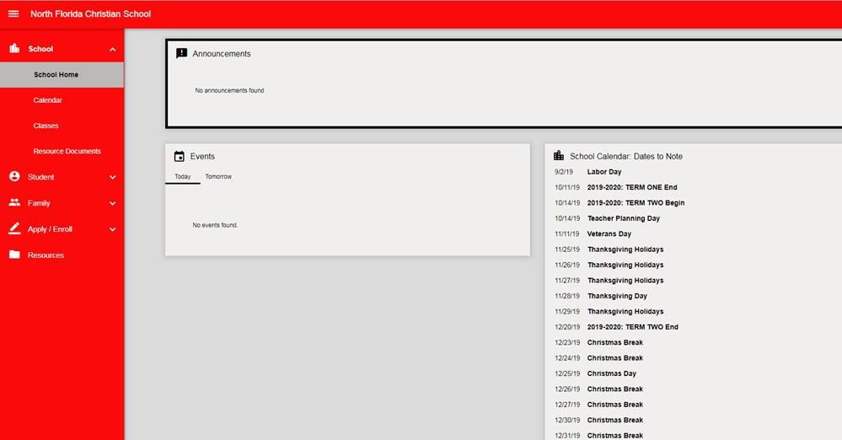

On the home screen, you’ll see the school calendar, and a list of any special events or notifications in the middle.  To the left, you’ll notice several different menus.  If you click on “Student”, you can see your student’s grades, lesson plans, homework assignments, behavior and attendance reports, and medical records.  If you click on “Family”, you should see a family billing box on the bottom left of the page. From here, you can pay your tuition or load money onto your student’s lunch account. More information on this is sent from the business office.

**PARENTS WEB HELPFUL TIPS**  
1. Be sure that when you enter your email address, that you are using the SAME email you used/provided previously to NFC during the application process. That way, we can link you to the right student’s account.

2. Parents Web is best accessed on a computer or laptop; the software does not respond well to tablets or cell phones.

3. You will not be able to update your own contact information within Parents Web, since the information is fed through our student system. Should you need to update your contact information during the school year, please reach out to the office in your student’s building with the corrected information and we will get it updated for you internally.